**DEPARTMENT OF MECHANICAL ENGINEERING**

**INDIAN INSTITUTE OF TECHNOLOGY (BHU)**

**VARANASI – 221005**

**ME-291: EXPLORATORY PROJECT**



**Group-11**

**Title**: Development of 3-D Printed water-based battery

**Submitted To:**

* Prof Santosh Kumar

**Submitted By:**

* Hritik Mittal (20135049)
* Aditya Katiyar (20135009)
* Naresh Kumar Meena (20135079)
* Keshu Pandre (20135060)
* Kartik Ningaraj Yanigar (20135059)

**Indian Institute of Technology (Banaras Hindu University)**

**Varanasi - 221005**

**Acknowledgement**

We would like to extend our sincere gratitude to Prof Santosh Kumar, professor in the Department of Mechanical Engineering, IIT-BHU (Varanasi) for allowing us to pursue this exploratory project under his valuable guidance. During this project he guided us and help us by providing the material used in this project.

Also, thanks to the laboratory staff of Department of Chemistry for providing us material used in this project. We are also thankful to Power Electronics Laboratory for providing us Multimeter device.

**Abstract**

A battery is a device consisting of one or more electrochemical cells with external connections for powering electrical devices such as flashlights, mobile phones, and electric cars. Batteries come in many shapes and sizes, from miniature cells to huge battery banks. Because of higher pollution and its hazardous effect on environment, uses of batteries has started in different devices.

Aluminium–air batteries (Al–air batteries) produce electricity from the reaction of oxygen in the air with aluminium. They have one of the highest energy densities of all batteries. However, an electric vehicle with aluminium batteries has the potential for up to eight times the range of a lithium-ion battery with a significantly lower total weight. This is eco-friendly in nature with greater availability. With low cost we can generate more electricity.

The aluminium air battery is considered to be an attractive candidate as a power source for electric vehicles (EVs) because of its high theoretical energy density (8100 Wh kg), which is significantly greater than that of lithium-ion batteries (LIBs).

However, some technical and scientific problems preventing the large-scale development of Al air batteries have not yet to be resolved. In this review, we present the fundamentals, challenges and the recent advances in Al air battery technology from aluminium anode, air cathode and electrocatalysts to electrolytes and inhibitors.

**Table of Contents: -**

1. **Introduction**6
2. Comparison of Al-air battery costs to internal combustion engines (ICEs): 7
3. **Materials Used** 8
4. **Procedure** 9
5. **Theory Used** 10
6. **Advancements in technology**………………………………………………12
7. Extending the life of low-cost, lightweight Al-air batteries……………………………………………………………………….. 12
8. Improvement of Aluminum–Air Battery Performances by the application of Flax Straw Extract…………………………………… 14
9. **Comparison of properties of various metal air batteries**…… 16
10. Advantage ……………………………………………………………………. 18
11. Disadvantage………………………………………………………………… 19
12. **Result** ………………………………………………………………………………… 20
13. **References**……………………………………………………………………………25

**Introduction: -**

Modern day society is at present in an alteration phase from a fossil fuel-based economy to the clean energy alternatives required to minimize environmental pollution. So, many renewable energy sources are being searched such as solar, wind, and hydropower. It is also important to search for secure, well-grounded and efficient energy storage technologies with the capability to be used in large-scale applications.

An aluminium – air water-based battery offers an attractive combination of low cost, lightweight, ultrahigh energy density and high specific capacity of 2.98 Ah/gAl. These batteries convert chemical energy directly into electrical energy. The aluminium air battery is considered to be an interesting candidate as a power source for electric vehicles because It have high theoretical energy density. 3D-printed batteries have appeared as a class of unique energy storage devices with excellent quality of microscale dimensions and ornamental diversity, which are essential to miniaturized and customized electronics. Understanding 3D printing designs in battery materials and architectures is key to optimize performance and realize the customization of 3D-printed batteries. Al-based batteries may offer significant cost savings and safety improvements over Li-ion batteries as these possess lower reactivity, easy handling, and greater safety.

**Comparison of Al-air battery costs to internal combustion engines (ICEs): -**

|  |  |  |  |
| --- | --- | --- | --- |
| Cost component | Al air | | ICE’s |
| Current | Projected |
| Fuel cost (cents/km) | 4.2 | 3.2 | 3.1 |
| Purchase price (US$) | 20,150 | 20,150 | 15500 |
| Life cycle cost (cents/km) | 26.8 | 25 | 22.0 |

3D printing technology, i.e., additive manufacturing (AM), is a completely bottom-up manufacturing technology capable of rapidly fabricating geometrically complex architectures with minimal material wastage and low cost. Overall, 3D printing technology opens a set of new avenues for the rapid fabrication of batteries or micro batteries with distinctive architectures and high performance.

**Materials Used: -**

* Aluminium foil
* Scissors
* Activated charcoal
* Paper towels
* Salt and KOH
* Small cup
* Water
* Two electrical leads with clips on the ends
* A small electrical device (such as a battery-powered DC motor)
* Masking tape
* Multimeter
* Copper Wire

**Procedure**

1. Cut a piece of aluminium foil that is approximately 9cm x 6.7 cm in size.

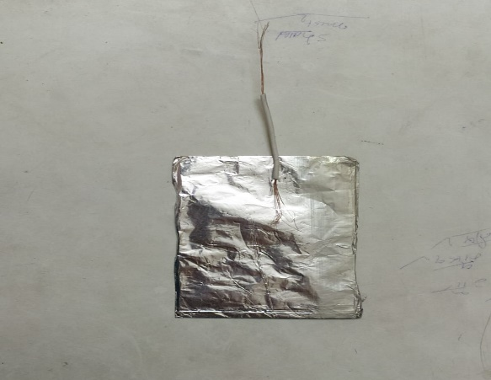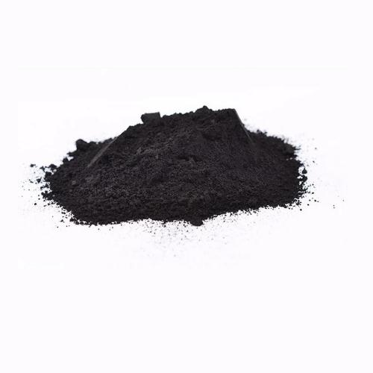

Aluminium foil Carbon Powder

1. Prepare a KOH-water solution of 1 molar concentration.
2. Connect copper wire to all the aluminium card.
3. Fold a paper towel into fourths, dampen it with the solution, then place the towel on the foil.
4. Add a heaping spoonful of activated charcoal on top of the paper towel, then gently crush the charcoal into fine bits using the back of the spoon. Pour some of the electrolytic solution onto the charcoal until it is dampened throughout. Make sure the charcoal doesn't touch the foil directly; you should have three distinct layers, like a sandwich.
5. Now the Battery is ready for use. We connected battery terminal to small LED bulb, attach a small piece of tape to the end of the bulb and we can see the lightening bulb.

**Theory Used: -**

Al–air batteries create electricity from the reaction of oxygen in the air with aluminium. They have one of the highest energy densities of all batteries, but they are not generally used because of problems with high anode cost and by-product removal when using traditional electrolytes. Also, we used copper foil and graphite to making this battery. Copper thin films have been commonly recognized for different materials owing to their high-quality magnetic, mechanical, wear resistance, anti-biofouling, and their good electrocatalytic properties. In a timely response to overviewing the progress, this article reviews significant progress in 3D-printed batteries, focusing on the connection between printing techniques and printable battery materials as well as the rational design considerations. In the process the aluminium is completely consumed to produce aluminium hydroxide. The metal air battery has a very attractive energy density because part of the reactants come from the air.

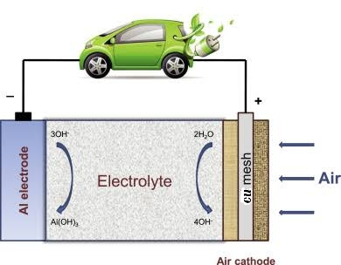

The anode oxidation half-reaction is: -

Al + 3OH− → Al (OH)3 + 3e− −2.31 V.

The cathode reduction half-reaction is

O2 + 2H2O + 4e− → 4OH− +0.40 V

The balanced equation is

4Al + 3O2 + 6H2O → 4Al (OH)3 +2.71 V

(The reaction improves if it is done in a basic solution that supplies excess OH ions. With potassium hydroxide electrolyte the 1.2 volts is produced with salt .7 volts per cell. Be very cautious if experimenting with NaOH electrolytes, use gloves and eye protection)

**Advancements in technology: -**

* **Extending the life of low-cost, lightweight Al-air batteries: -**

This technique overcomes the problem of corrosion in aluminium-air batteries by introducing an oil barrier between the aluminium electrode and the electrolyte — the fluid between the two battery electrodes that eats away at the aluminium when the battery is on standby. The oil is rapidly pumped away and replaced with electrolyte as soon as the battery is used. As a result, the energy loss is cut to just 0.02 percent a month — more than a thousandfold improvement.

Other methods involve pumping the liquid electrolyte out during storage and back in before use. These methods still enable significant corrosion and can clog plumbing systems in the battery pack. Because aluminium is hydrophilic (water-attracting) even after electrolyte is drained out of the pack, the remaining electrolyte will cling to the aluminium electrode surfaces. The batteries have complex structures, so there are many corners for electrolyte to get caught in, which results in continued corrosion.



To demonstrate the ability of aluminium to repel oil underwater, the researchers plunged this sample of aluminium into a beaker containing a layer of oil floating on water. When the sample enters the water layer, all the oil that clung to the surface on the way down quickly falls away, showing its property of underwater oleophobicity

A key to the new system is a thin membrane placed between the battery electrodes. When the battery is in use, both sides of the membrane are filled with a liquid electrolyte, but when the battery is put on standby, oil is pumped into the side closest to the aluminium electrode, which protects the aluminium surface from the electrolyte on the other side of the membrane.

The new battery system also takes advantage of a property of aluminium called “underwater oleophobicity” — that is, when aluminium is immersed in water, it repels oil from its surface. As a result, when the battery is reactivated and electrolyte is pumped back in, the electrolyte easily displaces the oil from the aluminium surface, which restores the power capabilities of the battery

**Improvement of Aluminium–Air Battery Performances by the Application of Flax Straw Extract: -**

**Straw poll**: Flax straw extract added to strong alkaline solution acts as a mixed-type Al corrosion inhibitor. The electrochemistry of Al in alkaline solution and in the presence of a flax straw extract added to the alkaline solution, as well as the effect on the Al morphology, surface films formed, and the corrosion inhibition mechanism are discussed. Al–air cells that use alkaline solutions that contain the flax straw extract show a markedly higher discharge capacity compared with other alkaline electrolytes.

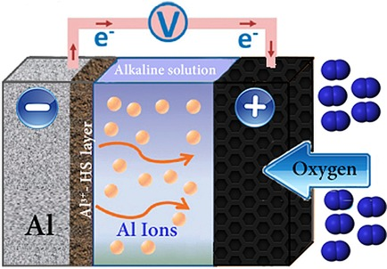

The effect of a flax straw extract on Al corrosion inhibition in a strong alkaline solution was studied by using electrochemical measurements, weight-loss analysis, SEM, and FTIR spectroscopy. Flax straw extract added (3 vol %) to the 5 M KOH solution to act as a mixed type Al corrosion inhibitor. The electrochemistry of Al in the presence of a flax straw extract in the alkaline solution, the effect of the extract on the Al morphology and surface films formed, and the corrosion inhibition mechanism are discussed. Finally, the Al–air battery discharge capacity recorded from a cell that used the flax straw extract in the alkaline electrolyte is substantially higher than that with only a pure alkaline electrolyte. This improved sustainability of the Al anode is attributed to Al corrosion inhibition and, consequently, to hydrogen evolution suppression.

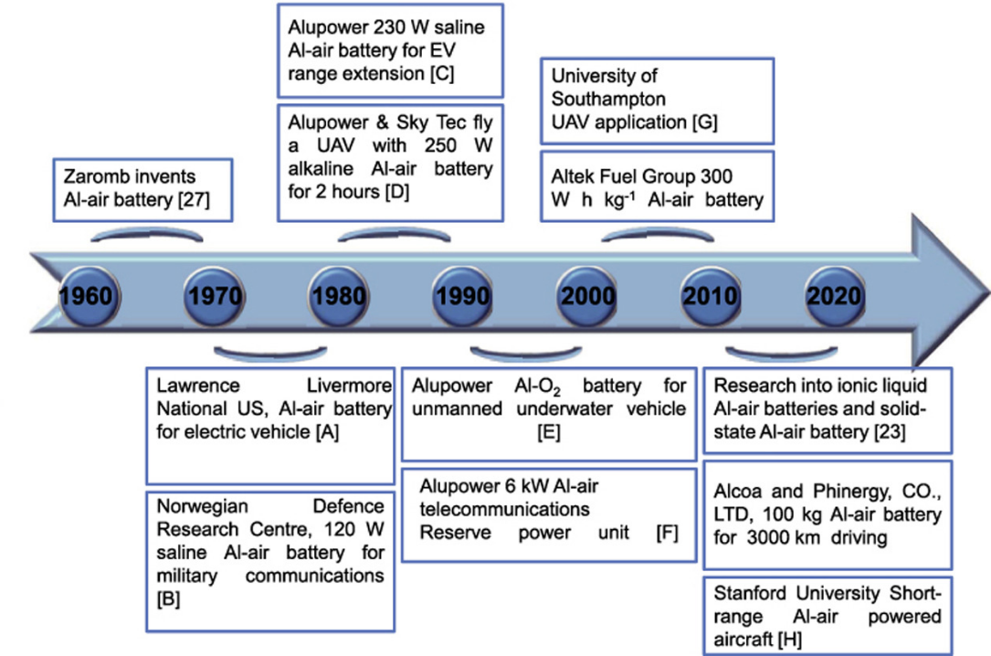

**Comparison of properties of various metal air batteries: -**

Parameter of various metal air batteries are as follows: -

|  |  |  |  |  |
| --- | --- | --- | --- | --- |
| Batteries | Theoretical Voltage (V) | Theoretical specific capacity (Ah Kg−1) | Theoretical energy density (kWh kg−1) | Practical operating voltage (V) |
| Li–air | 3.4 | 1170 | 13.0 | 2.4 |
| Zn-air | 1.6 | 958 | 1.3 | 1.0-1.2 |
| Mg-air | 3.1 | 620 | 6.8 | 1.2-1.4 |
| Na-air | 2.3 | 687 | 1.6 | 2.3 |
| Al-air | 2.7 | 1030 | 8.1 | 1.2-1.6 |

Among the metal–air batteries shown in Table, the Li–air battery shows the highest theoretical energy density (13000 Wh kg−1), which is significantly greater than other rechargeable battery technologies. Nonetheless, rechargeable Li–air batteries still have many challenges to overcome such as the blocking of porous carbon cathodes by discharge products, instability of lithium in [humid environments](https://www.sciencedirect.com/topics/engineering/humid-environment) , insufficient understanding of catalytic mechanism , low electrochemical efficiency owing to high charging overpotentials , and side product (such as lithium alkyl-carbonates and Li2CO3) formation during cycling . These issues negatively affect the reversible charging and cycle life of Li–air batteries.

Among the previously discussed metal–air batteries, Al–air batteries hold great promise for future large-scale energy applications due to their lowest cost and high theoretical specific capacity of 2.98 Ah g−1, which is the second highest only to that of lithium (3.86 Ah g−1) and much higher than those of magnesium (2.20 Ah g−1) and zinc (0.82 Ah g−1). Additionally, aluminium is an inexpensive, abundant and environmental friendly metal with high [recyclability](https://www.sciencedirect.com/topics/engineering/recyclability) . The Al–air battery has a high theoretical voltage (2.7 V) and energy density (8.1 kWh kg−1), far surpassing that of state-of-the-art LIBs.

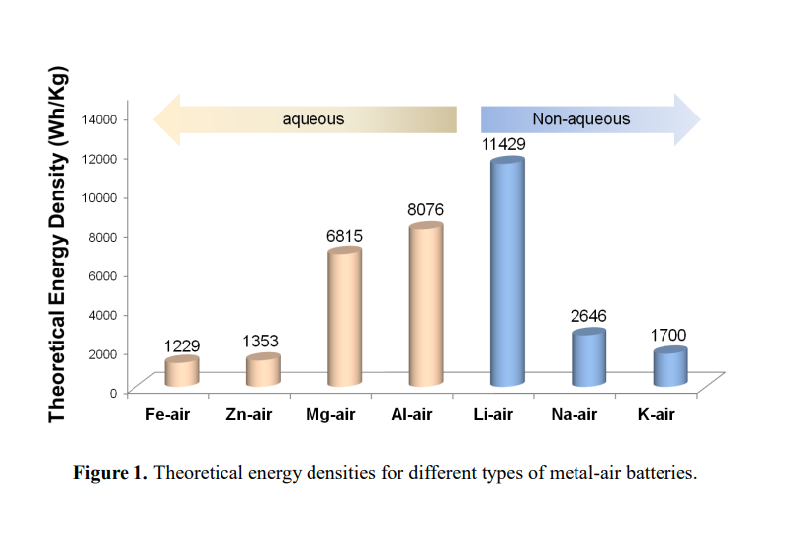

**Advantage:-**

* Low environmental impact - Recycling Al-Air batteries can be very simple. Aluminum recycling infrastructure already exists. Beyond the use of aluminum as a power source for electric vehicles, there are other interesting applications: scrap metal recycling applications can use this technology to recycle scrap metal, for example, unused airplanes, and a generate electricity at the same time. Another potential application could be recycling magnesium and aluminum casings on nuclear fuel rods, which are otherwise a highly radioactive, unusable material. It can then be used to produce green energy for use at the nuclear site.
* Lighter weight - Their energy density is an order of magnitude higher than that of lithium-ion cells, which enables them to be lighter, more compact and deliver a much greater driving range than today's electric vehicles.
* Cheaper- Aluminum is very cheap and can be recycled easily.
* Aluminum air batteries do not require electricity as they do not require charging and thus are one of the biggest blessings for electric vehicles and its user.
* The aluminum hydroxide solution generated in the used battery can be sent to a recycling unit to get 100% aluminum back. Aluminum air batteries are 100% recyclable and thus safe for the environment.
* Aluminum air battery technology is safe because it uses only a water-based electrolyte that is free of toxins, in contrast to lithium-ion technology that uses highly flammable organic toxins-based electrolytes. And as a result, aluminum air batteries are EV thermal friendly.

**Disadvantage: -**

* Just as an internal combustion vehicle needs to be refueled, an Al-Air battery needs to be raised above the water "every few hundred kilometers.
* a potential challenge is that Al-Air cells cannot be recharged conventionally. The aluminum is consumed in response to generate electricity, providing a driving range of a few thousand kilometers before the anodes have to be replaced. This can prove to be a cumbersome task and requires the establishment of a battery-swapping network.

**Result: -**

First, we prepare a single cell and measured its voltage and it found to be 0.41V. After that we prepare another 13 cells. We connected all the cells in series connection. On adding cells in series connection its overall voltage increases.

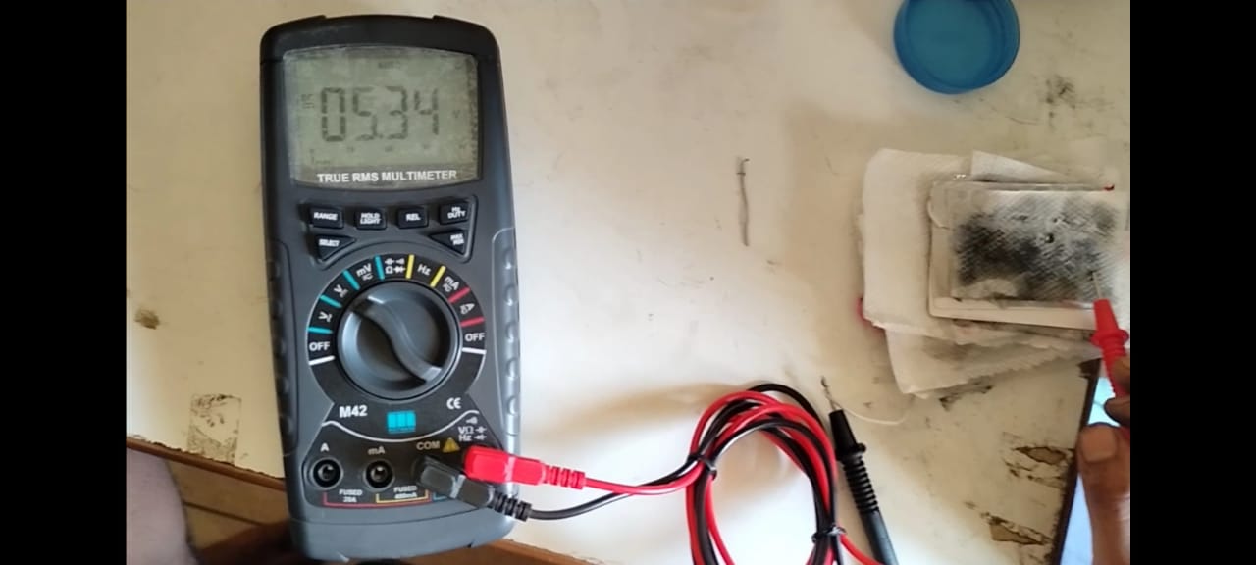

Overall Voltage of Battery measured by multimeter

* Furthermore, the study also suggested that a hydrophilic cathode is favorable to enhance the liquid-electrode contact and increase the performance of the battery. Although a high concentration limits the discharge capacity of an aluminum-air battery, the voltage stabilizes at a higher value for higher concentrations of electrolytes. This is because a stronger alkali has better ionic conductivity and facilitates better ionic motion. High amounts of OH− ions are available in the electrolyte solution and react with aluminum at the anode to generate electricity. It also helps to reduce the resistance to ion movement in the separator. Therefore, a compromise exists between the electrolyte concentration, discharge capacity, and operating voltage of an aluminum-air battery. However, increasing the concentration of electrolyte has no effect on the open-circuit voltage of the battery. The specific capacity increased as the anode utilization improved. As the concentration increases, the corrosion rate increases which leads to poor anode utilization. Some of the aluminum reacts with OH- ions to form aluminum hydroxide, thereby reducing the utilization of the anode leading to a drop in the specific capacity. Higher concentrations of electrolyte always show the lowest specific potentials. This suggested that the effects of corrosion are too severe for batteries using high concentrations of electrolyte. During the electrochemical reaction, an aluminum anode was consumed to generate energy and aluminum hydroxide was produced as a by-product. Measuring the weight of aluminum anodes before and after the electrochemical process can help to understand the corrosion rate of aluminum anodes. Since the density of aluminum hydroxide (2.42 g cm) is lighter than that of aluminum (2.70 g cm), the weight loss can be attributed to the formation of aluminum hydroxide during the electrochemical process. The corrosion rate is positively correlated with the weight loss of the aluminum anode.

In the above graph we have shown the effect of voltage on increasing the number of cells in a battery. All the cells are connected in series connection.

Voltage (in V)

* 3D printing of advanced batteries has drawn considerable attention as an innovative technology that can disruptively change the design and architecture at all levels of materials, modules, and devices. In this review, we examined the recent progress in 3D-printed batteries from the angles of

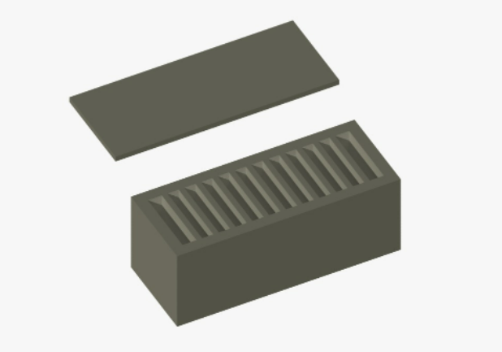

Design forCasing of Battery

printing techniques, printable materials, and design considerations at both modules and full cell device levels, aiming at providing readers with a comprehensive understanding of the 3D-printed batteries and their great application potentials.

Above design can be 3-D printed by printer and can be used as a casing of a battery.

**References: -**

* Zhiyang Lyu, Gwendolyn J.H. Lim, J. Justin Koh, Yi Li, Yanwen Ma, Jun Ding, Jinlan Wang, Zheng Hu, John Wang, Wei Chen, Yunfei Chen,

Design and Manufacture of 3D-Printed Batteries, Joule,

Volume 5, Issue 1,

2021,

Pages 89-114,

ISSN 2542-4351,

<https://doi.org/10.1016/j.joule.2020.11.010>.

(<https://www.sciencedirect.com/science/article/pii/S2542435120305183>)

* Yisi Liu, Qian Sun, Wenzhang Li, Keegan R. Adair, Jie Li, Xueliang Sun,

A comprehensive review on recent progress in aluminum–air batteries, Green Energy & Environment,

Volume 2, Issue 3,

2017,

Pages 246-277,

ISSN 2468-0257,

<https>[://doi.org/10.1016/j.gee.2017.06.006](https://doi.org/10.1016/j.gee.2017.06.006).

(<https://www.sciencedirect.com/science/article/pii/S246802571730081X>)

* P. Goel, D. Dobhal, R.C. Sharma,

Aluminum–air batteries: A viability review, Journal of Energy Storage,

Volume 28,

2020,

101287,

ISSN 2352-152X,

<https>[://doi.org/10.1016/j.est.2020.101287](https://doi.org/10.1016/j.est.2020.101287)

(<https://www.sciencedirect.com/science/article/pii/S2352152X1931391X>)

* <https://www.sciencedirect.com/science/article/pii/S246802571730081X>
* <https://www.sciencedirect.com/science/article/pii/S2542435120305183>
* <https://www.cei.washington.edu/wp-content/uploads/2018/12/Aluminum-air-battery.pdf>
* [https://www.researchgate.net/publication/245105485_Design_and_analysis_of_aluminumair_battery_system_ for_electric_vehicles](https://www.researchgate.net/publication/245105485_Design_and_analysis_of_aluminumair_battery_system_%20for_electric_vehicles)
* <https://news.mit.edu/2018/metal-air-batteries-extending-life-1108>